HEXTON JMI SCHOOL
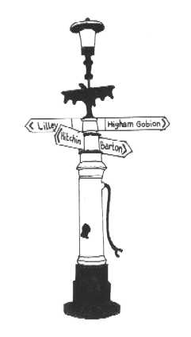

GOVERNING BODY INFORMATION 2021-22

Name | Governor Type | Role and Committee Membership | Appointing Body | Register of Business/Pecuniary Interests | Start of Term of Office | End of Term of Office
Lee Burgess | Co-opted | Vice Chair  Chair of Resources | Governing Body | None | 23/05/19 | 22/05/23
Kirstie Gran | Parent | SEN & Curriculum | Parent Election | None | 26/09/20 | 25/09/24
Mark Hall | Parent | Chair & Resources | Parent Election | None | 08/03/19 | 07/03/23
Roli Okoturo | Staff | Curriculum | Staff Election | Teacher at Hexton School | 20/07/18 | 19/07/22
Colette Pidgeon | Interim Head | Interim Head | Ex Officio | Part Secondment from Pirton School | 01/09/21
Antony Wallace | Co-opted | Safeguarding | Governing Body | None | 02/07820 | 01/07/24
Karen Ireland | Co-opted | Curriculum | Governing Body | Governor at a Bedfordshire School | 01/10/21 | 01/10/25

Resigned Governors 2020-21

Name | Governor Type | Role and Committee Membership | Appointing Body | Register of Business/Pecuniary Interests | Start of Term of Office | End of Term of Office
Sonia Fenner | Head | Headteacher | Ex Officio | Also works at Pirton School | 01/09/18 | 31/08/21
Steven Moore | Local Authority | Vice-Chair  Chair of Resources | Governing Body | None | 21/02/17 | 20/02/21

Attendance at Full Governing Body Meetings 2020-2021

Name | Governor Type | 01/10/20 | 23/11/20 | 20/01/21 | 11/03/21 | 04/05/2021 | 30/06/2021  Extraordinary Meeting | 12/07/2021
Lee Burgess | Co-opted |  | x |  | x | x |  | x
Sonia Fenner | Head
Kirstie Gran | Parent | n/a
Mark Hall | Parent
Steven Moore | Local Authority |  |  |  | n/a | n/a | n/a | n/a
Roli Okoturo | Staff
Colette Pidgeon | Associate & Deputy Head |  |  |  |  | x
Antony Wallace | Co-opted |  | x

